SYNAPSE
Detailed Design Document

Prepared By | Checked By | Approved By
SYNAPSE Team

Change Log
Release | Date | Changes | Author

Table of Contents
1. Introduction 5
1.1. Purpose and Scope 5
1.2. Structure of the Document 5
1.3. Reference Documents 5
1.4. Acronyms 6
2. Detailed design 7
2.1 Overview 7
2.1.1 Mission objectives 7
2.1.2 System Requirements 8
2.1.3 CONOPS and Operational Modes 10
Mode / Transition Trigger Conditions 10
Operational modes 10
1.5. On-board Computer Subsystem 12
1.5.1. Requirements covered 12
1.5.2. Electrical Schemas 12
1.5.3. Software structure 12
1.5.4. Perfboard Design 13
1.5.5. Components Tradeoff 14
1.6. Communications 16
1.6. Payload Subsystem 18
1.6.1. Requirements Covered 18
1.6.2. Akida models 18
1.6.3. Pre-processing Techniques 18
1.6.4. Image processing pipeline 18
1.6.5. Camera setup 23
1.6.6. Risk Analysis 23
1.6.7. Components Tradeoff 23
1.7. Thermal and Structure Subsystem 23
1.7.1. Requirements Covered 23
1.7.2. Structure design 24
1.7.3. Thermal experiments 25
3.3.4. Thermal Design via Software 26
2. Budgets 26
2.1. Power 26
2.2. Mass 26
2.3. Financial 26
3. Testing 27
3.1. Subsystem level testing 27
3.2. System testing 27
4. Operations 27
4.1. Flight Gondola 27
4.2. Planned flight 27
4.3. Pre-flight Check List 27
5. Post Flight Data Analysis and Future Improvements 27
6. Tables and Figures 27

1.Introduction

1.1 Purpose and Scope
This document provides a detailed description of the SYNAPSE project at the implementation level, covering the on-board computer, communications, thermal, structure and payload subsystems, as well as their integration and interactions.

Structure of the Document
This document is structured as follows:
- Section 1: Introduction
- Section 2: The design of the experiment, covering all subsystems and integrations
- Section 3: The financials, together with mass and power budgets
- Section 4: The testing that have been performed
- Section 5: Operation section, which summarizes the flight conditions and launch day planned actions
- Section 6: Expected outcomes of the experiment and ways of improvement
- Section 7: Annexes

Reference Documents

The following are the referenced documents

Issuer | Title | Release | Details
ROSPIN | Rospin Technical Project Workflow | 10/02/2025 | Outlines the main project management techniques used in a technical project inside ROSPIN.

Acronyms

Acronym | Meaning

2. Detailed design

2.1 Overview

2.1.1 Mission objectives

The mission has 3 main objectives. First, our goal is to classify on-board images of the ground using Spiking Neural Networks. Secondly, we plan to measure different flight and atmosphere parameters. Our last objective is that the experiment maintains its integrity throughout the entire flight. The project also has educational expected outcomes for its members:
- improving team work
- learn communication and management skills
- improving technical skills in one or multiple areas.
Starting with the 3 mission objectives, we have defined over 15 Mission Requirements, which can be found below.

ID | Title
MR-001 | Emergency Response
MR-002 | Atmospheric Pressure Measurement
MR-003 | Internal Temperature Measurement
MR-004 | Visible Light Intensity Measurement
MR-005 | Ground Imaging
MR-006 | Real-Time Geographical Positioning
MR-007 | Post-Mission Recoverability
MR-008 | Mission Energy Independence
MR-009 | Data Preservation
MR-010 | Bidirectional Ground Station Communication
MR-011 | On-Board Image Classification
MR-012 | Gondola Compatibility
MR-013 | External Temperature Measurement
MR-014 | Expected Flight Profile Compatibility
MR-015 | Acceleration Variations
MR-016 | Autonomous Operations

2.1.2 System Requirements

Going forward from the mission requirements, we defined the system requirements. They roughly define the type of components that we plan to use, the environmental restrictions and the compatibility factors for the balloon platform.

They consist of:

ID | Parent req | Enunciation | Details
SR-001 | MR-001 | The system shall detect any electrical, software, structural or thermal blockages.
SR-002 | MR-001 | The system shall prioritize experiment integrity in the event of electrical, software, structural or thermal blockages.
SR-003 | MR-002 | The system shall include a barometric sensor.
SR-004 | MR-003 | The system shall include at least 1 temperature sensor inside the enclosure. | Temperature range that is acceptable for batteries inside.
SR-005 | MR-004 | The system shall include at least 1 light sensor placed in the exterior of the enclosure. | Stratoshpere value.
SR-006 | MR-005 | The system shall include one camera facing ground.
SR-007 | MR-006 | The system shall include a GPS.
SR-008 | MR-007 | The system or the launch gondola shall include a back-up GPS tracker.
SR-009 | MR-008 | The system shall include its own acumulators.
SR-010 | MR-009 | The system shall inlcude at least one SD card.
SR-011 | MR-010 | The system shall include one LoRa tranceiver in air and one on the ground.
SR-012 | MR-011 | The mission shall perform onboard edge-AI classification of ground surface features (e.g., urban, water, forest) with a neuromorphic processor.
SR-013 | MR-011 | The system shall take clear pictures of the ground.
SR-014 | MR-012 | The experiment shall have a total mass of less than 1.5 kg.
SR-015 | MR-013 | The experiment shall include an exterior temperature sensor.
SR-016 | MR-014 | The system shall operate during exposure to ambient external temperatures ranging from -60°C to +45°C and ambient atmospheric pressures down to 10 mbar ± 2 mbar
SR-017 | MR-014 | The system shall be protected against condensation.
SR-018 | MR-014 | The system shall be designed to prevent electromagnetic interference between its components.
SR-018 | MR-10 | The system shall transmit live telemetry and AI classification results to a designated ground station.
SR-019 | MR-10 | The system shall contain a custom-made ground control station.
SR-020 | MR-15 | The system shall contain one accelerometer.
SR-021 | MR-16 | The system shall contain one on-board computer.

2.1.3 CONOPS and Operational Modes
The mission follows a strict sequence of operational combinations based on the flight phase. During the ground preparation sequence, all modes are cycled through at an accelerated pace before launch.
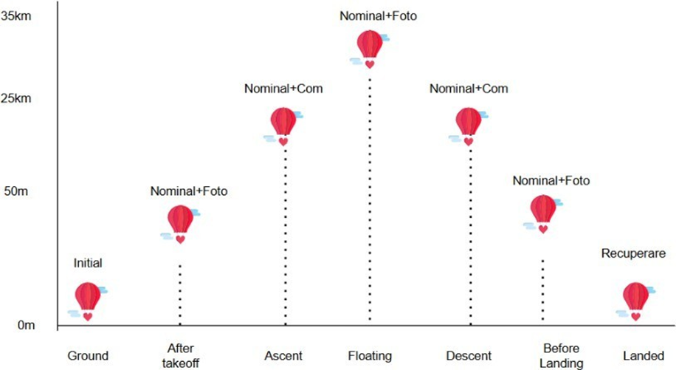

Figure 1.2: Flight stages and their associated operational

System states transition automatically based on sensor readings.

Mode / Transition Trigger Conditions
Photo Mode Entry/Exit Altitude 0-50m via Barometer + GPS.
Data Processing Mode Free fall detection (9.8 m/s²) + GPS + Barometer.
Safe Mode Any temperature sensor > 50◦C, or V_{bat} < threshold for 10s
Recovery mode Barometer, GPS and IMU flatline (constant) after a pre landing impact strike
Table 1.1: Sensory triggers for operational mode changes

Operational modes
This chapter covers data processing benchmarks. The systems run smoothly at peak loads. Metrics show steady performance across all global nodes. The infrastructure scales seamlessly.
The payload operates in several specific modes to optimize data collection and power consumption.
• Nominal Mode: The primary state for recording atmospheric and flight data.
• Photo Mode: Runs alongside Nominal Mode. Captures 1 pic/sec below 50m (takeoff and landing) and 2 pics/km between 25-35km, plus extra photos if the landscape changes by roughly 15%.
• Data Processing Mode: Nominal mode combined with onboard data processing.
• Data Transmission Mode: Transmits buffered data via LoRa without accepting ground commands. Activates every 10 minutes during ascent and float, and trans-mits processed data continuously below 15km on descent.
• Safe Mode: Emergency state triggered automatically by low battery or critical temperatures. Disables all systems except GPS, alerts the ground, and saves the transition to memory.
• Recovery Mode: Post-landing state where the GPS and internal temperature sensor remain active, transmitting coordinates via LoRa every 30 minutes.
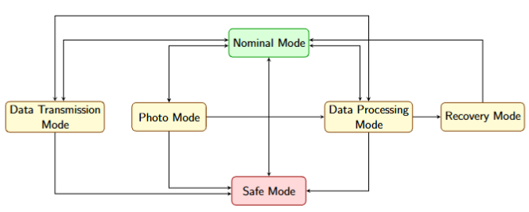
Figure 1.1: Operational modes and possible transitions

On-board Computer Subsystem

OBC is the central coordinator of the project, managing the communication between different parts of the system, such as sensors, camera, ground station and payload. Its main functionalities are reading sensor data, logging it, sending telemetry and managing potential problems or commands during the flight.
OBC switches between different modes based on the situation:
- normal mode = everything is running at full capacity
- low power mode = if power is running low, then other parts are required to save energy
- safe mode = if something goes wrong, it switches to bare minimum functions
The OBC subsystem collects data from all the sensors and keeps it organized in a shared library (Datapool).

Requirements covered

ID | Requirement
OBC-02 | The location system shall use a GPS module with high altitude support.
OBC-03 | The system shall transition to Low Power Mode if the battery voltage drops below the threshold of 14.0 V for a continuous period of at least 5 seconds.
OBC-04 | The system shall implement a Master/Slave hardware architecture where the ESP32 as the Master OBC and the Raspberry Pi 5 as the Slave payload.
OBC-07 | The OBC shall acquire data from all the on-board sensors at a specified rate.
OBC-11 | The OBC shall change its operational state upon receipt of a command from the GS
OBC-27 | The OBC shall write all sensor data, Pi 5 classification labels, and system states to a local SD card in CSV format.

OBC-02 - GPS with high-altitude support
We use NEO-M8N which allows to keep the GPS lock above 18 000m, which we need since the balloon goes way higher than that.

OBC-03 - Low Power Mode below 14.0 V
The idea is that if the battery gets low, the system should save power to last longer and improve our chances of recovering it. Right now it is handled by the mode manager, which checks battery voltage every 500ms and switches to Safe Mode when it’s too low - in Safe Mode, the IMU turns off, telemetry drops to once every 60s, and only the GPS and communications stay on.

OBC-04 - Master/Slave architecture
ESP32 is the Master and handles everything flight-related (sensors, power, safety logic). The Raspberry Pi is the slave and only runs the Akida classification. This way, if the Raspberry Pi crashes, the ESP32 notices and can cut its power without disrupting the rest of the system. The important parts never depend on the more complex and less predictable payload side.

OBC-07 - Acquire sensor data at a specified rate
The sensor task reads the barometer, GPS, IMU, light sensor, battery and temperature sensor once per second normally. In Safe Mode, it slows down to once every 10 seconds to save power.
OBC-11 - Change state on command from Ground Station
Commands from the ground are received and sorted by the packet router, which recognizes a mode-change command type.
OBC-27 - Log sensor data, Raspberry Pi 5 labels and system state to SD as CSV
All sensor readings (barometer, GPS, IMU, light, battery, temperature), classification labels received from the Raspberry Pi, and the current system state (mode, flight, phase) get written to the SD card in CSV format. Each row is timestamped so the data can be lined up in order and then crossed-checked against telemetry sent to the ground. This gives a backup of everythingcollected during the flight, so even if the LoRa link fails, nothing is lost, we can just read it straight off the SD card.

Electrical Schemas

Software structure
The OBC firmware runs on the ESP32 using FreeRTOS in subsystems/obc/esp32 - obc/main/. It is organized as it follows:
- Drivers - main/drivers/
- Datapool - main/system/datapool.h and datapool.c
- Tasks -main/tasks/
Each task handles one job, as it follows:
- sensors_task.c reads all sensors on a loop, then writes results into the Datapool. Reads 1 second normally, once every 10 seconds in safe mode.
- mode_manager_task.c every half-second checks altitude, vertical speed, battery and temperature from the Datapool, and determines both the flight phase (ground/ascent/float/descent/landed) and the mission mode (init/nominal/safe/recovery). Based on these, it decides which systems out of GPS, IMU, photos or comms) should be active and how often telemetry should be sent.
- packet_router_task.c receives incoming commands from the Raspberry Pi via a queue
- watchdog_sw.c is a background task that tracks other task’s heartbeat. If after 5 check-ins there is no heartbeat detected, then the system is restarted.
- main/main.c initializes the drivers, the Datapool, the watchdog and then starts the mode manager, sensor task, packet router and telemetry task. The main loop just repeats while tasks run independently.

The Raspberry Pi has its own codebase in subsystems/obc/src/ - main.py, control_servo.py, requirements.txt. The setup and run instructions can be found in the OBC README.md.

Perfboard Design
The OBC electronics are built around a perfboard that acts as the central hub for the subsystem. At its core is the ESP32, which connects out to every sensor and communication module through shared buses: I2C for the pressure sensor MS5607, light sensor GY-49, accelerometer ADXL345, current sensor INA219, vibration sensor; 1-wire for the temperature sensors; SPI for the LoRa module; UART for the GPS and the Raspberry Pi 5.
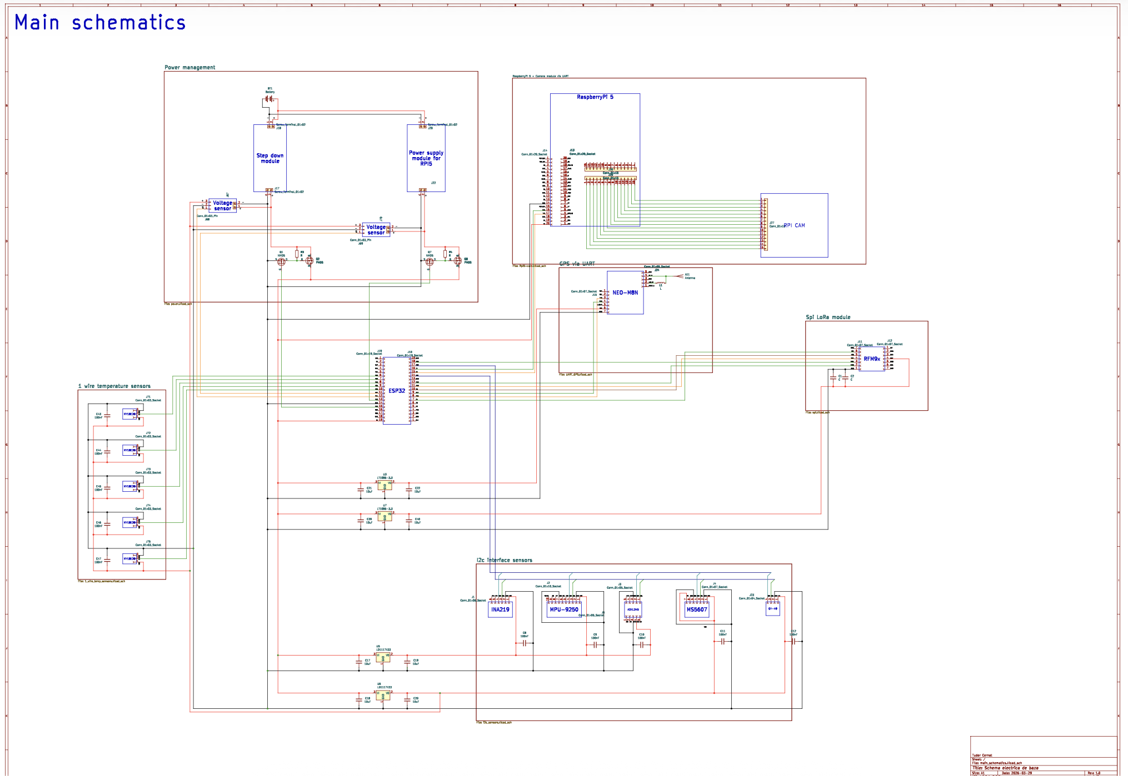

Components Tradeoff

Components were compared using a weighted scoring system, evaluated against the same criteria:
- Consumption - power draw
- Reliability - how consistently it works
- Performance - how well it does its job
- System impact - how much else needs to change to accommodate it
- Cost - price
- Availability - how easy it is to source
- Lead time - how long it takes to arrive
- Other - anything specific to that components

Each criterion gets a weight (0-1, summing to 1) based on how much it matters, each option is graded 1-5, and score = weight x grade. Totals are summed, and the highest-scoring option is chosen.

1.6. Communications

1.6.1. Requirements covered

ID | Requirement
COM-001 | The system shall send telemetry to the ground every 10 minutes.
COM-002 | The system shall send GPS data along with land classification labels in dedicated packets.
COM-003 | The system shall support bidirectional data transfer between the flight unit and the ground station over distances of up to 200km.
COM-005 | The ground station shall allow real-time monitoring of bidirectional communication.
COM-009 | The ground station shall provide a real-time map displaying land classification results.

1.6.2. LoRa Protocol
We chose the LoRa communication protocol because we have to send relatively small amounts of data (kbps) over a long range (100km+), but also because of its community support online and available hardware.

1.6.3. Flight Analysis and choosing the right parameters
Finding the right parameters for our system means

1.6.4. Hardware and software setup
We use 2 LoRa modules on the 433Hz frequency, with one 10 cm rubber-duck type of antenna for the experiment and one half-meter Yagi antenna for the ground station. As a microcontroller unit, on both sides we are going to use the ESP32 microcontroller.
Because of the sensitivity of the SPI protocol that the LoRa module works with, the first version of the perfboard was not suitable for the experiment, so we decided to build a custom PCB for the LoRa modules. A pinout diagram can be seen below.
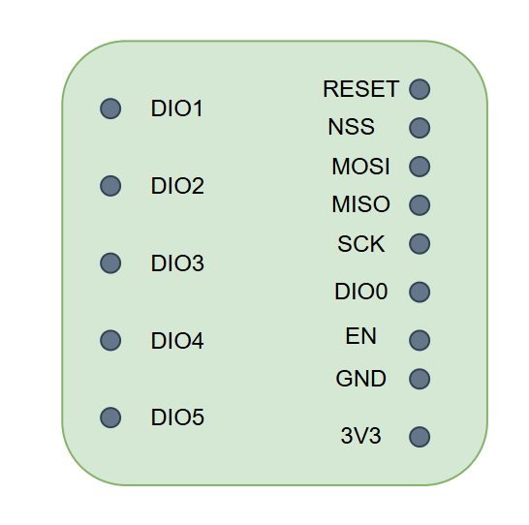
LoRa modules PCB pinout diagram
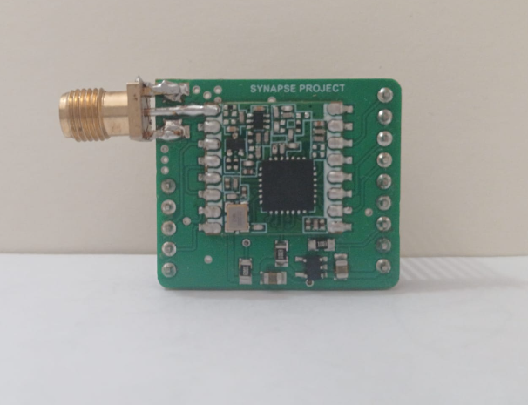
LoRa PCB with connector

In terms of telemetry packets, the scope of them is to give us a general overview regarding what is happening on-board of the experiment. We have to minimize redundant information and also stick to an approximate interval for the telemetry packets. Below there is a breakdown of relevant information that we want to include in the telemetry packets that we want to send every 10 minutes to the ground:

Sensor | Information
Exterior temperature sensor | Average measurement for the last 10 minutes
Interior temperature sensor(s) | Average measurement for the last 10 minutes
Light sensor | Average measurement for the last 10 minutes
GPS | Last coordinates measured
IMU | Last measurements
OBC | Internal parameters
Raspberry Pi | Internal parameters
Barometer | Average measurement for the last 10 minutes
Current sensor | Average measurement for the last 10 minutes

Telemetry packets content
We chose the 10 minute window because we do not plan to act upon the telemetry in real time, as our experiment shall be fully autonomous. But, if any unpredicted scenario appears, we may transmit commands to our experiment. The experiment shall be able to protect itself and take action if emergency situations appear during the mission, the main emergency mechanism being entering in the Safe Mode. If the experiment is not able to exit the Safe Mode, then we can see this after at most 10 minutes, which is an acceptable inactivity duration. Then, we can assess the situation and take corrective measures.
The second type of packets that we want to send to the ground are the image classification outcomes. We need to transmit the GPS coordinates of the pictures taken together with the classification labels of the terrain. Every picture that we take is made up of 2028 segments that are classified separately ( due to the Akida model constraints on accuracy). Having 10 classes, we will need 4 bits for each segment to represent the label. Combined with the GPS coordinates for longitude and latitude that account for 64 bits, each photo will need 8176 bits. Considering that the photos will be taken at the full resolution of our camera, the compression factor for each photo is x1000. Because the balloon will not move fast, we will select up to 5 photos that have the least amount of overlay and will process only those. Having this in mind, the size of the image classification packets will account for almost 40 624 bits of information that need to be sent to the ground.
The images will be reconstructed with our ground station software after we receive all the packets.

DE ADAUGAT APLICATIA

Payload Subsystem
The payload subsystem serves two main purposes: the first is handling the entire image processing pipeline, from capturing photos to selecting the information worth sending back to the ground; the second is collecting environmental and experiment data through our sensors.
- Barometric module
- Inertial measurement unit
- GPS module
- Light sensor
- Temperature sensor

Requirements Covered
The full Payload subsystem requirements are as follows:
Parent req ID | Title | Requirement | Type | Details
SR-003 | Barometric Sensor Range | The barometric sensor shall register values as low as 3 mbars. |  | Pressure at 40km altitude
SR-004 | Internal Temperature Sensor Range | The internal temperature sensor(s) shall support -10 to 60 degrees. |  | Temperature range that is acceptable for batteries inside.
SR-005 | Light Sensor Measurement Range | The light sensor(s) shall measure visible light intensity in the range 0–120,000 lux. |  | Typical for stratosphere.
SR-006 | Ground Sampling Distance | The camera shall have the Ground Sampling Distance of at least 11m/ pixel. |  | Typical GSD for datasets used.
SR-006 | Selective Autofocus | The camera shall allow selective autofocus. |  | The camera cannot focalize on something in the stratosphere
SR-006 | Camera Compatibility | The camera shall be compatible with either the OBC or with the Raspberry Pi 5.
SR-006 | Narrow Field of View | The camera shall have narrow Field of View. |  | Images with wide FOV tend to be distorted near the edges.
SR-006 | Visible Spectrum Imaging | The camera shall take pictures in the visible spectrum.
SR-006 | Global Shutter | The camera shall have global shutter. |  | In movement, global shutter is better.
SR-006 | Adjustable Capture Parameters | The camera shall allow the change of capture parameters. |  | In different light conditions, automatic change of exposure is a must.
SR-007 | GPS Positioning Precision | The GPS shall register position with a precision at least equal with the GSD. |  | at least 10-11m. If the image precision is 10m, then the gps shall be at least the same.
SR-010 | Sensor Data and Photo Storage | The payload system shall store all sensor data an photos on a SD card, together with timestamp and coordinates.
SR-012 | Akida Processor Compatibility | The payload shall include an Akida processor compatible with a Raspberry Pi 5.
SR-012 | AI Classification Models | The payload software shall include Akida-compatible models for image classification.
SR-012 | Image and Classification Geotagging | The payload system shall associate each captured image and AI classification result with a GPS timestamp and coordinate tag.
SR-012 | Minimum Photo Capture Rate | The payload subsystem shall process at least 5 capture photos.
SR-012 | Best Photo Selection | The payload software shall chose the best photos for processing. |  | considering biggest area covered and height.

Akida models

The Akida model is used for on-board image classification within the SYNAPSE payload. The model runs inference on the Akida neuromorphic accelerator and is integrated into the image processing pipeline. The developed workflow uses satellite images as input, which are processed before being classified by the model.
The model is intended to classify satellite imagery based on the EuroSAT dataset. As part of the implemented pipeline, large images are segmented into 64*64 image patches, which are subsequently provided to the Akida Model for classification. The complete processing chain is structured as image capture, image division, and inference.
The overall role of the Akida model within the image processing pipeline is illustrated in the following figure:

Pre-processing Techniques

Image processing pipeline
Below we have the software architecture of the payload part that handles the acquisition and processing of the ground images.
We implemented 2 different functionalities that will add on top of the nominal mode in order to create the data processing mode and the photo mode. Both components live on the Raspberry Pi 5.
First, the functionality of the data processing mode is described in Diagram 1.

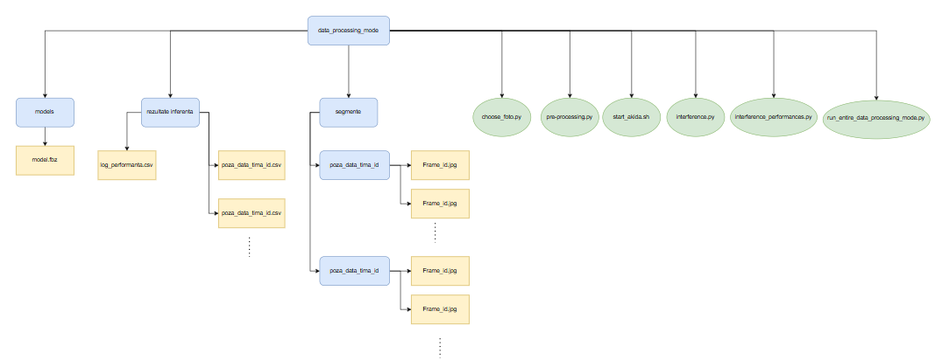
Diagram 1
data_processing_mode (root folder)
This is the main folder on the Raspberry Pi that contains the entire ground-processing pipeline, both the scripts that do the work and the data folders where results accumulate. Everything below lives inside it.
models/ folder → model.fbz
- Holds the pretrained Akida neural network file (the classifier).
- This is input, not output. Nothing in the pipeline writes to it, it's just loaded and used.
- It's what tells the system how to classify each tile as AnnualCrop, Forest, Residential, etc.
rezultate_inferenta/ folder (inference results)
This is where every run's output ends up. Inside it:
- log_performanta.csv a performance log. One new row gets appended every time the full pipeline runs, recording:
  - number of photos processed
  - number of tiles/frames processed
  - total time taken
  - average time per frame
  - frames per second (FPS)
  - This lets you compare speed across multiple runs over time.
- poza_data_timp_id.csv (one per photo) the actual classification output. Each row corresponds to one 64x64 tile of that photo and lists which class the model predicted for it.
segmente/ folder (segments/tiles)
- Holds the sliced-up version of each selected photo.
- One subfolder per photo (named after the photo), and inside each subfolder, the individual 64x64 pixel tiles as Frame_id.jpg.
- This folder gets completely emptied and rebuilt on every run, so tiles from an old run never mix in with a new one.
choose_foto.py (this is choosing_foto.py in the actual code)
Step 1 of the pipeline. What it does, in order:
- Reads log_pozitii.csv from foto_mode (all captured photos + their metadata).
- Filters out any photo taken below 25km altitude too low to be useful.
- From what's left, picks at most 20 "candidate" photos, chosen specifically to spread out geographically as much as possible (so you don't waste time checking near-duplicate shots).
- Runs a clarity check on just those 20 candidates: looks at blur, overexposure/underexposure, cloud cover, and haze.
- Picks the best 5 photos (again favoring geographic spread among the clear ones), and copies them into a photos_for_akida folder for the next step.
pre-processing.py
Step 2 of the pipeline. What it does:
- Takes the 5 photos chosen in step 1.
- Pads each image if its dimensions aren't an exact multiple of 64 pixels (adds black padding).
- Cuts each image into a grid of 64x64 tiles.
- Saves the tiles into segmente/, organized into one subfolder per original photo.
start_akida.sh
Step 3 of the pipeline , a shell script, not Python, because it needs to manage Docker and hardware drivers. What it does:
- Checks whether the Akida PCIe driver is already loaded on the system; loads it if not.
- Starts a Docker container (the Akida hardware can only be accessed from inside this container).
- Mounts the data_processing_mode folder into the container so the container can see the tiles and write results back out.
- Runs inference.py inside that container.
- Guarantees the container gets stopped and cleaned up afterward even if you hit Ctrl+C partway through.
interference.py (this is inference.py in the actual code)
Step 3b runs inside the Docker container, not on the host directly. What it does:
- Loads the trained model from models/.
- Goes through every photo-subfolder inside segmente/.
- Runs the model on every tile in that subfolder.
- Writes one results CSV per photo into rezultate_inferenta/, listing each tile's predicted class.
- Times the whole run and appends a summary row to log_performanta.csv.
interference_performances.py (this is inference_performances.py)
Step 4, the final step runs back on the host (no Docker/Akida hardware needed, it's just reading files). What it does:
- Reads every results CSV in rezultate_inferenta/ and counts up class labels, both per-photo and overall.
- Reads log_performanta.csv and prints a history of past runs: time taken, FPS, etc., plus averages across all runs.
- This is purely a reporting step it doesn't produce new data, just summarizes what's already there.
run_entire_data_processing_mode.py
The wrapper script was created to tie everything together. It's not really "data" in the diagram, it's the conductor:
- Runs choosing_foto.py
- Then pre-processing.py
- Then start_akida.sh
- Then inference_performances.py
- If any step fails (non-zero exit code), it stops immediately instead of continuing to the next step so you don't waste time processing garbage if, say, the photo selection step found nothing usable.

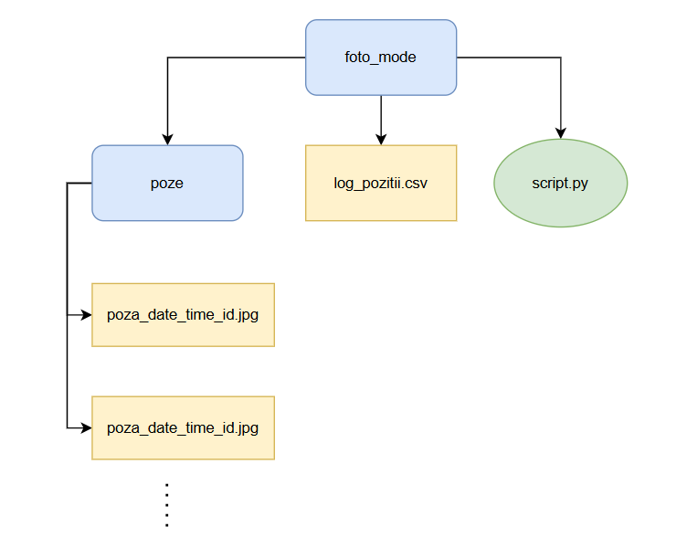
Diagram 2

Diagram 2 foto_mode (photo capture)
foto_mode (root folder)
This is the earlier stage of the whole system it runs on the camera side, capturing raw photos before any of the data_processing_mode steps happen.
poze/ folder (photos)
- Where every captured photo is saved.
- Filenames follow the pattern poza_<timestamp>_<index>.jpg.
log_pozitii.csv (position log)
- One row per photo captured, recording:
  - filename and timestamp
  - camera settings used (exposure time, gain, contrast, saturation, sharpness)
  - GPS data (latitude, longitude, altitude)
- This is the exact file choosing_foto.py later reads to decide which photos were taken high enough up (above 25km) to bother processing.
- Note: the GPS values are currently randomly generated as a placeholder there's a comment in the code saying this will be replaced once a real GPS module (like a NEO-6M/NEO-M8N) is wired in.
script.py
The capture script that runs on the Pi with the camera attached. What it does, in order:
- Starts the camera and lets it warm up briefly.
- Runs an auto-exposure calibration routine: tries several candidate shutter speeds, and for each one adjusts the gain until brightness hits a target level.
- Measures sharpness and the percentage of over/underexposed pixels for each candidate.
- Picks whichever shutter/gain combination gives the sharpest image while staying within acceptable exposure limits.
- Enters a continuous capture loop, taking one photo roughly every 2 seconds.
- For each photo: saves the image file into poze/, generates (currently fake) GPS coordinates, and appends a row with all the metadata to log_pozitii.csv.
- Keeps running until manually stopped with Ctrl+C, at which point it prints how many photos were taken and closes the log file cleanly.

Camera setup

Risk Analysis

Components Tradeoff

Thermal and Structure Subsystem

Requirements Covered
The thermal system is made of:
- Polystyrene casing, a standard of stratospheric missions
- The inside electronics that act as a heat source (especially the neuromorphic processor, the OBC and the Raspberry Pi 5)
The main problems that the thermal system has to solve are preventing the overheating of the electronic components and ensuring that the temperature of the batteries stays over -10 degrees (a threshold from where the batteries discharging performance starts to drop).
In terms of heat dissipation, the main heat sources on the electronics are covered with heatsinks.
The preliminary heat management tests performed show that inside the structure, the Raspberry Pi 5 tends to overheat in a significant way.
Tests have been performed (need improvement): https://docs.google.com/document/d/154AjDKufYRqoC5q3N18Zv99FVJRA_zDk2h-mKl-OHX0/edit?tab=t.0
From other ballooning teams or RISE, the polystyrene casing seems to be enough. So we are not going to use active heaters, because our electronics already act like a heater.
The main blindspot when it comes to thermal is experimenting with temperatures that are very low for a prolonged time. We can make sure that we prevent overheating. But we cannot assess how it will behave in the stratosphere, so we have to build a robust system.

Title | Requirement
Autonomous Thermal Control | The experiment shall ensure autonomously the recommended inside temperature envelope.
Passive Heat Dissipation | The system shall passively dissipate thermal load generated by the electronics.
Overheated Component Power-Off | The experiment shall power-off over-heated components.
On-Board Electronics Thermal Management | The experiment shall manage the internal temperature via the control of the electronics on-board
Camera Lens Anti-Condensation/Anti-Icing | The experiment shall avoid the condensation or ice on the camera lens.
Enclosure Condensation Prevention | The experiment shall prevent condensation inside the enclosure.
Main Structure | The main structure shall accommodate all the components.

Structure design

The structure of the system has the role to enclose and act as a mechanical backbone for the experiment. Because during the balloon launch and landing, the mechanical stress for the experiment will not be that great, we chose as material Polyethylene Terephthalate Glycol-modified (PETG) because of its reduced costs. Further, the structure had to support layers of electronics as shown below in Figure x:
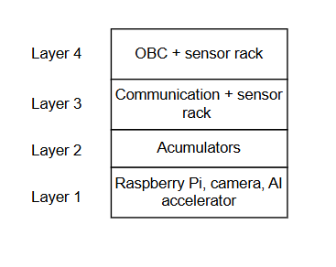
Configuration of the experiment

On top of the experiment, we will have the on-board computer, together with some of the sensors. In the same are, the barometric sensor and the GPS antenna will be exposed to the exterior. On the second layer, the LoRa module antenna will be placed in the exterior, together with the light sensor. At the bottom, the camera will also be exposed to the exterior. Beside these placements, the rest of the electronics will be fixed inside the enclosure, where they have to be kept within operational temperature range. As most of the heat emitted inside comes from the Layer 1, and the batteries are the most important thing to keep warm, and we also have to keep a low center of gravity and the batteries will be the most heavy parts, we chose this configuration.
We used a 2U configuration for the structure, available online here. The structure weighs 310g.

Thermal experiments
We have mainly an experimental approach towards designing the thermal system. As a methodology, we enclose the electronics that generate most of the heat inside and run on them the 2 tasks that are supposed to run onboard: capturing photos and processing the images. We split these 2 into 3 more granular tasks: capture, pre-processing (run on Raspberry Pi) and image processing (run on Akida).
Experiment 1: Layer 1 inside the structure, heatsinks present for Rasp Pi
Conditions: 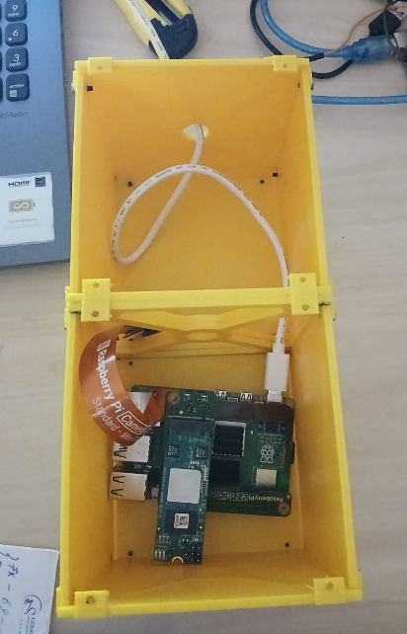
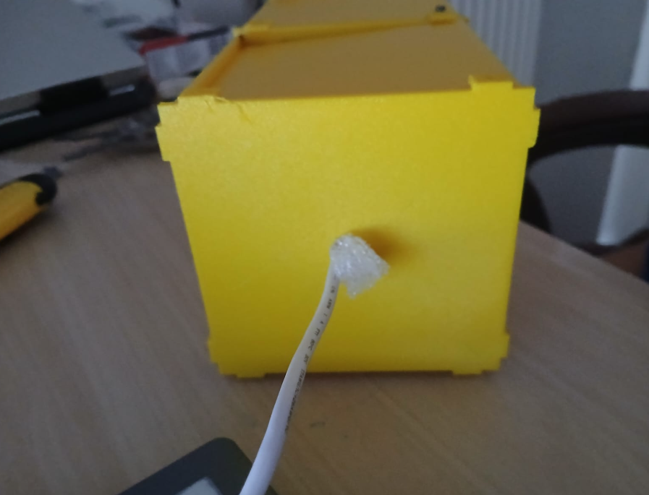
Results: 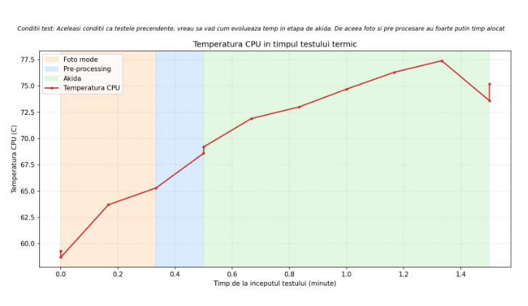
Experiment 2: Layer 1 inside the structure, heatsinks present for both Rasp Pi and Akida + fan
Experiment 3: Full electronics box, insulation, room temperature, temperature control
Experiment 4: Full electronics box, insulation, freezer -> is it needed at all?

1.7.4. Thermal Design via Software

Budgets

Power

Mass
https://docs.google.com/spreadsheets/d/1UxqbSwSM5OTMwyGbR7cQcAlUwsn04R40LehsfcOQFls/edit?gid=2002210831#gid=2002210831

Financial
https://docs.google.com/spreadsheets/d/1UxqbSwSM5OTMwyGbR7cQcAlUwsn04R40LehsfcOQFls/edit?gid=1331779163#gid=1331779163

Testing

Subsystem level testing

System testing

Component | Test Objectives | Steps | Outcomes and Obervations
Barometric module MS5611 | 1. Confirm I2C communication and calibration data are readable.  2. Confirm pressure readings are accurate across the expected range.  3. Confirm the sensor is stable over long continuous operation. | 1. Init sensor over I2C, read calibration coefficients, verify ADC commands.  2. Sweep a calibrated pressure chamber from 300–1100 mbar, compare to a reference sensor.  3. Run continuously for 72h, logging pressure/temperature every second. | Communication test passed, no CRC errors. Accuracy only checked informally (~10m altitude difference); formal chamber test and 72h stability test still pending.
Camera | 1. Confirm the camera is detected and initializes correctly over CSI.  2. Confirm images stay in focus and usable while stationary and while moving at balloon-like speeds (10–20 km/h), across resolutions.  3. Confirm the camera recovers normally after a disconnect. | 1. Connect via CSI, start video stream, check for driver/init errors.  2. Capture photos standing still and moving, at multiple resolutions including max resolution.  3. Disconnect and reconnect the camera, check it comes back online. | Detection and init pass reliably. Indoor blur traced to slow shutter in low light, not hardware. Adaptive shutter script tested separately with a moving marker (Laplacian blur detection + auto shutter capping) — no blur at 0.5 m/s. Full outdoor test at balloon speed (10-20km/h) still pending. New risk found: lens condensation/pressure damage risk, needs mitigation before flight.
Light Sensor VEMLS7700 | Verify basic function, dark-state behoaviour, visible light rejection, UV response, and mechanical robustness | 1. Power on, read output.  2. Cover fully, check dark value.  3. Shine visible light, check for false reaction.  4. Apply UV, check response.  5. Shake/drop test, check connectors/solder joints. | Sensor configured and reading correctly - reports both visible light (ALS) and total light including infrared, confirmed via live sensor task logs. Dark, visible-light-rejection, UV-response, and mechanical robustness tests not yet performed.
Current Sensor INA219 | Verify I2C communication, calibration/scaling, and accuracy of current/voltage readings against an external reference. | 1. Configure sensor, confirm I2C communication.  2. Calibrate/scale readings.  3. Compare readings against external measurement (power supply/multimeter). | Communication and calibration working correctly. Tested at both 12V and 5V setups against a lab power supply: at 12.00V/0.178A reference, INA read ~11.95V/0.17-0.18A; at 5.00V/0.076A reference, INA read ~4.98V/0.07-0.08A — readings closely match the external reference in both cases, confirming accurate measurement.
IMU MPU9250 | Verify I2C communication, correct 3axis acceleration readings, and ability to detect acceleration changes (for vibration detection). | 1. Configure sensor, confirm I2C communication.  2. Verify 3axis acceleration output.  3. Move/shake the sensor and check it registers the variation. | Manually moved the sensor in different directions, and the reported acceleration values responded correctly.
Temperature sensor MY18E20 | Verify room temperature reading, see responses for warm/cold, response time, vibration robustness. | 1. Read room temperature  2. Expose to cold.  3.Expose to warm.  4. MOve rapidly between temperatures, measure stabilization time.  5. Shake/drop test on mounted sensor. | Basic testing done and results were good.
GPS GYNEO6MV2 | Verify GPS acquisition and correct parsing of positioning data. | Run the GPS code near a window to get a satellite fix. | Initially not working, but found the root cause: the parser only recognised GPRMS and GPGGA NMEA sentences, but the module was actually sending GN prefixed sentences (combined GNSS mode). Worked correctly after the fix.
LoRa Module RFM95 | Verify PCB/power integrity, transmission reliability, link recovery, sleep current and packet delivery rate at range. | 1.Inspect PCB/voltage rails.  2. Send first packet RSSI/SNR/CRC.  3. Force disconnect, check auto-recovery.  4. Stress test TX under load + check sleep current.  5. Sustained packet delivery rate over time and distance. | Range test was done: Arduino Nano + LoRa module on both ends (Ground station with Yagi antenna, satellite side with a compact antenna), transmitting at only approx 10% of the module’s maximum power. Reliable inception indoors at 3-4m and outdoors at 300-500m.
Akida chip | Verify classification accuracy and measure interference performance on real hardware. | Run interference on some test images through the Akida chip, log per-class accuracy and timing stats. | On a 100 image test batch, 87/100 were classified correctly, 13 were wrong. Total processing time 1.26s, averaging 12.59ms per image. Per-area breakdown: 10/10 for Residential, 8/10 for River and 10/10 for SeaLake.
Raspberry Pi | Verify boot reliability, undervoltage behaviour, current draw under different loads, and thermal throttling behaviour. | 1.10x cold boot cycles, measure time to mission script active.  2. Slowly drop supply voltage 5.1V→4.5V, watch for undervoltage flags.  3. Measure current draw idle/peak/logging.  4. Stress CPU, monitor throttling near 80°C. | It was only exercised indirectly as part of full-system integration testing alongside the other components, not as a dedicated standalone test.
ESP32 | Verify UART stability under vibration, brownout threshold, power draw in active and sleep modes, and regulator thermal behaviour under load. | 1. Vibrate board, watch UART for corrupted output.  2. Slowly drop supply voltage 5V→3V, note brownout point.  3. Measure power in active vs. deep sleep.  4. Run CPU-intensive load at 5.5V, measure regulator temperature. | Not run as a standalone isolated test — tested together with the other components as part of full-system integration, and passed without issues observed.
Memory Card |  |  | not tested yet

Operations

Flight Gondola

Planned flight

Pre-flight Check List

Post Flight Data Analysis and Future Improvements

Tables and Figures

